
Macquarie University Postgraduate Research Fund (PGRF)

Conference Paper/Poster & Travel Application

APPLICATION FORM

Before completing this form applicants must read the Macquarie University PGRF Funding Rules and note that non-compliance with the Funding Rules may lead to the application being deemed ineligible.

In particular, applicants should note the following:

- The PGRF is intended to enhance the postgraduate research experience and add value to the thesis – it is not to be used to meet basic research and infrastructure costs associated with the applicant’s candidature.

- One of the main aims of the PGRF is to give applicants firsthand experience of the grant writing process. Applications will be assessed on the written application alone.

- The maximum value of the grant is $5,000. Applicants submitting budgets in excess of this amount must demonstrate how the extra expense will be met, e.g. Departmental/Faculty funds.

- Applications must not be handwritten, must be submitted in not less than 12-point font type, and must not be double sided or stapled.

- A “Supervisor’s Report Form” must be submitted independently of the application by the closing date. Applications for which no Supervisor’s Report Form is received by the closing date will be ruled ineligible.

- Conference travel costs will be considered only where the applicant has had a paper accepted or is making a poster presentation. Where such evidence is not available at the time of application, it must be submitted to the Faculty HDR Manager prior to the release of funds.

- Advice regarding account details and administration of the funds including reimbursements, payment of airfares, etc, is handled via the Departmental/Faculty Finance Offices.

Macquarie University Postgraduate Research Fund (PGRF)

Conference paper/poster travel application

DVC-R commendation |  |  |  |  |  |  | (If Yes)
1. Applicant
Family name | Kelley |  | Given name |  |  | Douglas
Student number | 42056055 |  | Email | douglas.kelley@students.mq.edu.au
Home phone # | 0468790426 |  | University phone #
*Department | Biological Sciences
*Faculty | Science
Research degree | Phd Ecology |  |  | Enrolment date |  |  |  |  | 30/06/10
 |  | Load |  |  | F/T P/T
* This address will be used for all official correspondence.

2. Amount requested |  | $4091
3. Thesis title
Effects of climate change on Australian fire regimes
4. Thesis project summary
Provide an informative plain language summary of your research (100 words maximum). Identify the thesis project’s main aims, its significance within the field, and the expected research outcomes.
Fire is an important aspect of vegetation dynamics in Australia, maintaining diversity and vegetation structure. It is influenced by the local vegetation types and productivity and climate.
LPX, a dynamic vegetation model that explicitly simulates fire dynamics, has the potential to provide a useful new tool untangle these various influences on fire – essential in order to determine change in fire regime with future climate. My thesis focusses on improving LPXs simulation of fire and using it to explore the impacts of climate change on Australian fire regimes - the first time a process-based model will be used to assess future changes in fire.

5. Supervisors
Principal Supervisor
Family name | Harrison |  | Given name |  | Sandy | Title | Prof
Staff number |  |  |  | Email | sandy.harrison@mq.edu.au
Department | Biological Sciences
Faculty | Science

Supervisor 2
Family name | Medlyn |  | Given name |  | Belinda | Title | As. Prof
Staff number |  |  |  | Email | belinda.medlyn@mq.edu.au
Department | Biological Sciences
Faculty | Science

Supervisor 3
Family name | Prentice |  | Given name |  | Colin | Title | Prof
Staff number |  |  |  | Email | colin.prentice@mq.edu.au
Department | Biological Sciences
Faculty | Science

6. Stipend
Stipend source | International Macquarie University Research Excellence (iMQRES)
Amount | $24636 | Duration (mm/yy – mm/yy) | 06/10 – 12/13
7. Thesis progress - In no more than half of one A4 page, provide a brief summary of the progress of your thesis research to date, including what has been accomplished and what remains to be done to complete your thesis. Please attach Annual Reports.
My thesis is split into three components: development of a benchmarking system for assessing areas of LPX that need modifying to improve its simulation of fire (Kelley et al., 2012); applying these modifications to LPX (2nd paper in thesis); and using LPX to assess future changes in fire (third paper in thesis). The first two components form the bulk of my thesis.

I have completed the benchmarking system (published in Journal of Biogeosciences – Kelley et al., 2012), and I’m currently working on modifying LPX, based on extensive data analysis, to improve its simulation of Australian fire regimes. I have already modified: the way ignitions from lightning strikes are calculated; the decomposition rate of plant litter (which forms the fuel for fire); grass competition (which affects the production of fuel); and introduced a competitive adaptation of tree defines to fire via bark protection. The figure compares the models simulation of burnt area & tree cover against satellite observations and the original, Prentice et al. (2011) version (on which I was a co-author), showing a clear improvement in the models simulation of fire and its associated vegetation dynamics.

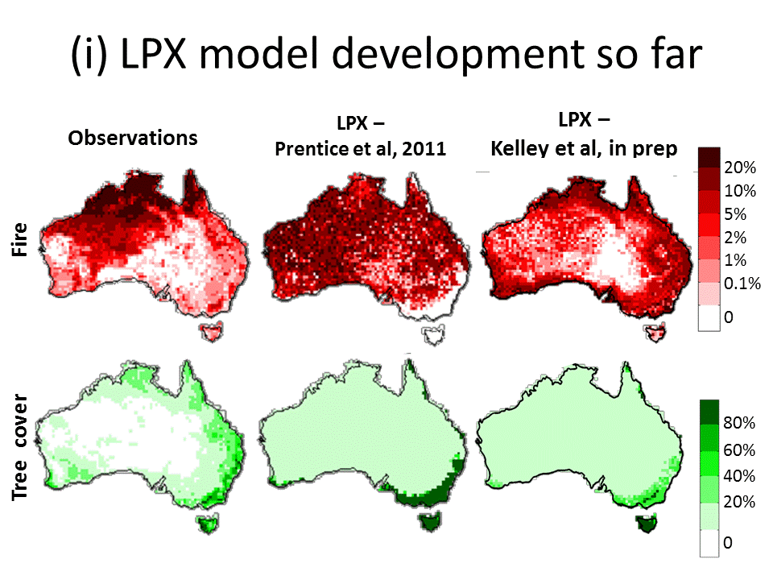
The last changes, which I am currently working on, are modifications to tree rooting depth (important for tree survival in semi-arid, fire prone regions); and plant resprouting, an important strategy for fire survival and regrowth. A paper describing these improvements will be submitted for publication this autumn. Once development is finished, the model will be used to assess the impacts of future climate change by driving it with climate model outputs from the CMIP5 future climate runs. This work will be the basis for my third thesis paper, which will be submitted in October 2013.

I will present the new model and future simulations at the AGU fall meeting.

8. Conference details
Conference name (include name of sponsoring organisation and conference theme, if relevant) | American Geophysical Union Fall meeting  The AGU Fall meeting attracts over 20,000 earth scientists every year, There are sessions on land-surface modelling and emissions, on vegetation dynamics, and on climate modelling -- my proposed paper will fit in any one of these sessions.
Conference dates and location | 9th – 13th December, San Francisco, USA
Paper/poster title | Projections of changes in Australian fire regimes during the 21st century.
Has your paper/poster been accepted for presentation? |  | No (abstract submission is not yet open)
Is proof of acceptance attached? |  | No
Awarded funds will not be released until such proof has been submitted to the Faculty HDR Manager

9. Conference attendance - Explain how attendance at the proposed conference is important and relevant, and will enhance your thesis
This is the final year of my thesis. Attending AGU will provide me with an opportunity to showcase my work and to discuss future collaborations in this area. It will also provide me with the opportunity to seek postdoctoral positions in the area of fire modelling.

LPX, the baseline model, is widely used by the vegetation and climate modelling community, and this presentation will enable me to show how the model has improved to the widest possible audience. In addition to advertising my own work, this will promote collaborations with my home group at Macquarie (Biosphere and Climate Dynamics) where continued development of the model will take place.

10. Value added to travel described in item 9
You are encouraged to seek extra opportunities to develop your research and add value to your project while you are overseas. Please provide details of other activities that will add value to your travel through visits to laboratories or research facilities etc.
I plan to visit Max Moritz, University of Berkeley, to discuss my results with him. Prof. Moritz is one of the leading experts in modern fire regimes and the prediction of future fire based on statistical methods.

11. Have you previously received support from the PGRF? | Yes | No
If Yes, have you received approval to re-apply? Attach evidence of approval. | Yes | No

12. Budget - List all expenses involved in attending the conference.

For guidance on legitimate budget items, please refer to the Funding Rules.

$
AGU Membership | $20
Conference Registration fee based on 2012 (2013 not released yet) | $195
Return flights between Sydney and San Francisco, quoted from STA travel | $2030
Accommodation, $107 a night for 6 nights stay, sharing with other conference guests. | $642
Accommodation, $214 a night for 3 nights stay Berkley visit | $642
Per diem at $96 a day for 9 days | $864
Return train to Berkeley | $8
$4091

13. Justification of the budget - Justify each budget item by clearly indicating why the amount requested is appropriate. Attach copies of quotes to the end of application form.

Confine your answer to half of one A4 page
AGU membership
Joining AGU, at a cost of $20, saves $55 on registration.

Conference Registration
This is the price quoted for the 2012 Fall meeting (2013 information has not been released yet) for Student conference attendees with AGU membership.

Flights
Flights were based on current quotes from STA travel for a return flight from Sydney to San Francisco

Accommodation
Accommodation costs are based on 2012 prices as 2013 not released yet (see attached invoice form a 2012 conference attendee). 6 nights are for sharing accommodation with another conference attendee (red box on the attached invoice), and 3 nights are for a single room during my visit to Berkley (blue box).

Per diem
I will be abroad for 9 days (5 conference days, plus two either side including visit to Berkeley). Per diem cost is based on the PGRF rules.

Berkeley train fare
This is the cost to travel to Berkeley to visit Max Mortiz.

AGU membership, conference registration, Accommodation and train fare in the attached quotes are in US$. However, conversion to Australian dollars is almost 1:1.

14. Additional costs - If conference attendance costs exceed $5,000, provide details of how you intend to meet the excess costs.
N/A

15. Ethics
Does your postgraduate research require human or animal ethical or biosafety approval? |  |  |  | Yes No
If yes, indicate the type/s of approval required | Human |  | Animal |  | Biosafety
If approval has been obtained, provide the reference number
Should you have any questions relating to ethical issues, please contact:
Ethics Secretariat
Email: ethics.secretariat@mq.edu.au
Telephone: 9850 6848

Funds will not be released until the appropriate approval/s have been received and until evidence of such approval/s has been provided to the Faculty HDR Manager.

16. Applicant certification

‘I certify that the information I have provided in this application form is true and correct.’

Name | Douglas Kelley | Signature
Date | 27/02/2013 | Signature

17. Principal/other Supervisor’s certification

I certify that the applicant's attendance at the cited conference is important and relevant to their thesis research, and the conference is a leading international level conference in this field. I understand that should this application be supported, failure of the applicant to adhere to PGRF reporting requirements will result in the awarded funds being recouped from my Department.

Name | Sandy Harrison | Signature
Date | 27/02/2013
Name | Belinda Medlyn | Signature
Date | 27/02/2013

18. Head of Department

I certify that this application is in accordance with the PGRF Funding Rules, and that any additional costs (above the Scheme maximum and defined as essential for the conference) cited in the application, will /will not be funded by the Department/Faculty. I also certify that where a student fails to provide a final report, should they be successful, that the Department will refund the value of the award.

Name |  | Signature
Date

19. Associate Dean HDR

I certify that this application is in accordance with the PGRF Funding Rules, and that any additional costs (above the PGRF maximum and defined as essential for the conference) cited in the application, will / will not be funded by the Department/Faculty.

Name |  | Signature
Date |  | Signature

Attachments - attach the following documents as relevant:
- Day-to-day itinerary
- Annual Report(s) (required for all applications)
- STA / Campus Travel quote
- Accommodation quote
- Evidence of conference registration fee
- Evidence of abstract acceptance (for example, email from conference organisers)
- Copies of invitations or correspondence confirming invitation to visit research facilities, laboratories, research groups etc

